**JSS MAHAVIDYAPEETHA**

**JSS SCIENCE AND TECHNOLOGY UNIVERSITY**

**JSS TECHNICAL INSTITUTIONS CAMPUS**

**MYSURU – 570006 KARNATAKA, INDIA**



“CLOUD EVENT - 01”

**INFORMATION SCIENCE AND ENGINNERING**

**Submitted by**

**Punith G S**

**(01JST22UIS405)**

**Sandeep C R**

**(01JST22UIS406)**

**Vedavyasa Mannur**

**(01JST22UIS409)**

**Submitted to**

**Dr. Manju N**

**(PROFESSOR)**

**DEPARTMENT OF INFORMATION SCIENCE AND ENGINEERING**

**MAY 2024**

1. **Table of Contents**
2. Introduction to AWS 2
3. Services offered by AWS4
4. Applications of AWS5
5. Advantages of using AWS6
6. Disadvantages of using AWS7
7. ElastiC COMPUTE CLOUD (EC2)
   * 1. Introduction8
     2. Implementation11
8. SIMPE STORAGE (S3)
   * 1. Introduction19
     2. Implementation 21
9. DYANAMODB
   * 1. Introduction24
     2. Implementation 26

10) SIMPLE NATIFICATION SERVICE (SNS)

i) Introduction28

ii) Implementation 30

**INTRODUCTION TO AWS**

Amazon Web Services (AWS) stands as a pioneering force in the realm of cloud computing, revolutionizing the way businesses leverage and manage their digital infrastructure. Established in 2006 by Amazon.com, AWS has evolved into an industry giant, offering a diverse suite of cloud services that cater to the dynamic needs of organizations worldwide.

**History of AWS:**

The genesis of AWS can be traced back to Amazon's own operational challenges. Managing the vast and fluctuating demands of Amazon's e-commerce platform required a scalable and cost-effective solution. Recognizing the potential to provide their robust infrastructure as a service, Amazon launched AWS with a vision to democratize access to advanced computing resources.

In its initial phase, AWS primarily offered fundamental services, including Simple Storage Service (S3) for storage and Elastic Compute Cloud (EC2) for scalable computing power. These foundational services laid the groundwork for AWS to expand its offerings and establish itself as a comprehensive cloud computing platform.

**Evolution and Growth:**

AWS's evolution has been marked by a relentless commitment to innovation. Over the years, AWS has continually introduced a plethora of services, ranging from computing and storage to machine learning, artificial intelligence, Internet of Things (IoT), and serverless computing. This expansive portfolio has enabled businesses of all sizes to embrace the cloud, driving agility, scalability, and cost-efficiency.

The transformative impact of AWS became evident as organizations across diverse industries migrated their operations to the cloud. Startups, enterprises, and even government agencies found in AWS a reliable partner for their digital transformation journeys. The platform's global presence, with data centers strategically located around the world, ensures low-latency access and compliance with regional data regulations.

**Key Offerings and Services:**

AWS's extensive range of services caters to virtually every aspect of modern computing needs. Amazon EC2 allows users to rent virtual servers in the cloud, providing scalable compute capacity. Amazon S3, a widely used object storage service, ensures secure and scalable storage for diverse data types. AWS Lambda, a serverless computing service, enables users to run code without provisioning or managing servers, facilitating seamless execution of event-driven functions.

Moreover, AWS has made significant strides in emerging technologies. Amazon SageMaker simplifies the deployment of machine learning models, making AI accessible to a broader audience. AWS IoT empowers organizations to connect and manage IoT devices at scale, fostering innovation in the realm of connected devices and smart systems.

**Global Impact and Market Dominance:**

AWS's global impact is underscored by its market dominance. As of my knowledge cutoff in January 2022, AWS maintained a significant lead in the cloud market share. Its vast customer base includes renowned brands such as Netflix, Airbnb, and NASA, attesting to its reliability and scalability. The platform's strategic partnerships with other tech giants and continuous investments in infrastructure ensure its continued influence in the cloud computing landscape.

**Conclusion:**

In conclusion, AWS has emerged as a transformative force in the world of cloud computing, reshaping the digital landscape for businesses and individuals alike. From its humble beginnings as an in-house solution for Amazon's e-commerce challenges to its current status as a global cloud computing powerhouse, AWS reflects a commitment to innovation, customer-centricity, and the democratization of advanced computing resources. As technology continues to advance, AWS is poised to play a pivotal role in shaping the future of cloud computing and digital transformation.

**SERVICES OFFERED BY AWS**

Amazon Web Services (AWS) offers a vast array of cloud computing services, catering to the diverse needs of businesses and developers. Here are 15 of the most widely used and essential AWS services:

**Amazon EC2 (Elastic Compute Cloud):** EC2 provides resizable compute capacity in the cloud, allowing users to run virtual servers for a variety of applications. It is fundamental to many cloud-based solutions.

**Amazon S3 (Simple Storage Service):** S3 is a scalable object storage service that enables users to store and retrieve any amount of data at any time. It is widely used for backup, data archiving, and serving static websites.

**AWS Lambda:** Lambda is a serverless computing service that lets you run code without provisioning or managing servers. It's ideal for event-driven applications and microservices architecture.

**Amazon RDS (Relational Database Service)**: RDS simplifies the setup, operation, and scaling of relational databases. It supports various database engines, including MySQL, PostgreSQL, and Oracle.

**Amazon DynamoDB:** DynamoDB is a fully managed NoSQL database service that provides fast and predictable performance with seamless scalability. It's commonly used for applications requiring low-latency access to data.

**Amazon VPC (Virtual Private Cloud):** VPC allows users to launch Amazon Web Services resources into a virtual network. It provides control over the network configuration, including selection of IP address range, creation of subnets, and configuration of route tables.

**AWS IAM (Identity and Access Management):** IAM enables users to securely control access to AWS services and resources. It allows the creation of users, groups, and roles with specific permissions.

**Amazon SNS (Simple Notification Service):** SNS is a fully managed messaging service that enables the decoupling of microservices, distributed systems, and serverless applications. It facilitates the sending of messages, notifications, and alerts.

**Amazon SQS (Simple Queue Service):** SQS is a fully managed message queuing service that enables the decoupling of components of a cloud application. It provides reliable and scalable queuing of messages between distributed systems.

**Amazon ECS (Elastic Container Service):** ECS is a fully managed container orchestration service that supports Docker containers. It simplifies the deployment, management, and scaling of containerized applications.

**APPLICATIONS OF AWS**

Various Application of AWS include:

**Website Hosting:** AWS is widely used for hosting websites, providing scalable and reliable infrastructure for organizations of all sizes.

**Mobile App Development:** AWS offers services for mobile app development, including storage, databases, and serverless computing for backend functionality.

**Data Storage and Backup**: Organizations use Amazon S3 for scalable and durable storage, and AWS Glacier for low-cost archival backup solutions.

**Big Data Analytics**: AWS provides services like Amazon EMR and Amazon Redshift for processing and analyzing large datasets, making it suitable for big data applications.

**Internet of Things (IoT):** AWS IoT services enable the connection, management, and analysis of IoT devices, facilitating the development of smart and connected solutions.

**Machine Learning and AI**: AWS offers a suite of machine learning services, such as Amazon SageMaker, for building, training, and deploying machine learning models.

**Content Delivery:** Amazon CloudFront, a content delivery network (CDN), accelerates the delivery of web content, videos, and other assets globally, enhancing user experience.

**Media Services:** AWS provides media services like Amazon Transcribe and Amazon Recognition for transcription, translation, and analysis of audio and video content.

**DevOps and Continuous Integration/Continuous Deployment (CI/CD):** AWS supports DevOps practices with services like AWS CodePipeline and AWS CodeDeploy for automating software development and deployment processes.

**Databases**: Amazon RDS and DynamoDB are used for managed relational and NoSQL databases, offering scalability, reliability, and ease of management.

**Virtual Private Cloud (VPC):** Organizations leverage AWS VPC to create isolated and customizable network environments for their applications.

**ADVANTAGES OF USING AWS**

**Scalability:** AWS provides on-demand scalability, allowing users to easily scale resources up or down based on changing workloads, ensuring optimal performance and cost-efficiency.

**Global Reach:** With data centers strategically located worldwide, AWS enables businesses to deploy applications and services close to end-users, reducing latency and improving user experience.

**Cost-Efficiency:** AWS follows a pay-as-you-go pricing model, allowing users to pay only for the resources they consume. This flexibility helps control costs and eliminates the need for large upfront investments.

**Security:** AWS implements robust security measures, including data encryption, identity and access management, and compliance certifications, ensuring the confidentiality and integrity of user data.

**Reliability and High Availability:** AWS offers a highly reliable infrastructure with redundant systems and data centres, minimizing downtime and ensuring high availability for applications and services.

**Flexibility and Choice:** AWS provides a wide range of services, allowing users to choose the tools and technologies that best suit their specific requirements, fostering flexibility and innovation.

**Elastic Load Balancing:** AWS ELB distributes incoming application traffic across multiple targets, ensuring even distribution and preventing overload on any single resource, improving application availability and fault tolerance.

**Global Content Delivery:** Amazon CloudFront, AWS's content delivery network (CDN), accelerates the delivery of content to users globally, reducing latency and enhancing the performance of web applications.

**Innovative Technologies:** AWS constantly introduces new services and features, staying at the forefront of technological advancements and enabling users to leverage the latest innovations in cloud computing.

**Hybrid Cloud Capabilities:** AWS supports hybrid cloud architectures, allowing seamless integration between on-premises data centres and the cloud, providing flexibility and facilitating gradual migration.

**DevOps Integration**: AWS offers a suite of tools for implementing DevOps practices, automating processes, and improving collaboration between development and operations teams.

**DISADVANTAGES OF USING AWS**

While Amazon Web Services (AWS) offers numerous benefits, there are also some potential disadvantages to consider:

**Cost Complexity:** AWS pricing can be complex, with various factors affecting costs, such as data transfer, storage, and compute resources. Without careful management, costs can escalate.

**Learning Curve:** For newcomers, AWS has a steep learning curve due to its extensive suite of services and features. Adequate training and expertise are essential for optimal utilization.

**Vendor Lock-in:** Adopting AWS services might create a dependency, making it challenging to migrate to another cloud provider without significant effort. This can lead to a form of vendor lock-in.

**Data Privacy and Compliance:** Depending on the nature of the data and the region of operation, navigating data privacy and compliance issues, such as GDPR, can be complex and may require additional efforts.

**Internet Dependency:** Many AWS services require an internet connection, making them less suitable for applications with strict offline requirements or in regions with limited connectivity.

**Service Outages:** While AWS has a robust infrastructure, occasional service outages can impact users, affecting the availability of applications and services.

**Complexity of Networking:** Advanced networking configurations in AWS, such as VPC peering and VPN setups, can be complex, requiring a deep understanding of networking principles.

**Limited Physical Control:** As a cloud service, users have limited control over the physical infrastructure, which may be a concern for organizations with strict regulatory or compliance requirements.

**Constantly Evolving Services:** While innovation is a strength, the constant introduction of new services and updates can necessitate ongoing training and adaptation for users to stay current.

**Resource Sharing**: In a multi-tenant environment, resources are shared among various users, raising potential security and performance concerns, although AWS implements strong isolation measures.

**Geopolitical Risks:** AWS data centres are located worldwide, and geopolitical events or regulatory changes in certain regions can impact service availability and data sovereignty.

**EC2 (ELASTIC COMPUTING CLOUD)**

**INTRODUCTION:**

Amazon Elastic Compute Cloud (EC2) stands as a foundational pillar in the realm of cloud computing. Since its inception in 2006, it has revolutionized the landscape by offering resizable compute capacity in the cloud. With EC2, users can effortlessly rent virtual machines, or instances, eliminating the burdens associated with managing physical hardware. This paradigm shift brings about significant advantages, including cost savings, scalability, and flexibility. EC2's elasticity allows users to seamlessly scale resources up or down in response to demand fluctuations, ensuring optimal performance without over-provisioning. Furthermore, its diverse range of instance types caters to various use cases, optimizing performance and cost-efficiency. The pay-as-you-go pricing model further enhances cost transparency, enabling businesses to manage their budgets effectively. Coupled with robust security features and seamless integration with the broader AWS ecosystem, EC2 empowers organizations to innovate and thrive in the digital era.

**Foundations of EC2:**

The foundation of Amazon EC2 (Elastic Compute Cloud) in cloud computing lies in its ability to provide resizable compute capacity in the cloud. Introduced in 2006, EC2 fundamentally changed how businesses think about computing resources by offering virtual servers that can be spun up or down on-demand.

At its core, EC2 is built upon a distributed infrastructure comprising data centers located across the globe. These data centers are organized into regions, which are further divided into Availability Zones (AZs). This design ensures high availability, fault tolerance, and low latency for EC2 instances.

Key components of EC2 include instances, which are virtual machines running within the EC2 environment. Users can launch instances from pre-configured Amazon Machine Images (AMIs) or customize their own images. Instances come in various types optimized for different workloads, such as general-purpose, compute-optimized, memory-optimized, and storage-optimized.

Another crucial aspect of EC2 is its network infrastructure. Each instance is associated with a network interface and can be assigned public or private IP addresses. Users can configure security groups and network access control lists (ACLs) to control traffic to and from instances.

EC2 also offers features like Elastic Block Store (EBS) for persistent block-level storage, auto-scaling to automatically adjust capacity based on demand, and Elastic Load Balancing (ELB) to distribute incoming traffic across multiple instances.

**Elastic compute cloud Features:**

Amazon Elastic Compute Cloud (EC2) offers a multitude of features that make it a cornerstone service in cloud computing:

* **Scalability:** EC2 enables users to scale their compute resources up or down based on demand, ensuring optimal performance without over-provisioning or underutilization.
* **Variety of Instance Types**: EC2 provides a wide range of instance types optimized for different workloads, including general-purpose, compute-optimized, memory-optimized, storage-optimized, and GPU instances.
* **Flexible Pricing Options**: EC2 offers various pricing models, including On-Demand Instances, Reserved Instances, and Spot Instances, allowing users to choose the most cost-effective option for their needs.
* **Elastic Block Store (EBS):** EC2 instances can be paired with EBS volumes, providing persistent block-level storage that can be easily attached and detached from instances as needed.
* **Security:** EC2 offers numerous security features, including network isolation, security groups, IAM roles, encryption at rest and in transit, and compliance certifications to help users secure their applications and data.
* **Integration with AWS Services**: EC2 seamlessly integrates with other AWS services, such as Amazon S3, Amazon RDS, AWS Lambda, and Amazon VPC, allowing users to build complex, scalable architectures.
* **High Availability and Reliability**: EC2 instances are deployed across multiple Availability Zones within a region, providing high availability and fault tolerance.
* Monitoring and Management: EC2 provides tools like Amazon CloudWatch for monitoring instance performance and AWS Systems Manager for managing instances at scale, making it easier for users to maintain their infrastructure.
* **Auto Scaling**: EC2 Auto Scaling automatically adjusts the number of instances in a group based on changing demand, ensuring that applications are responsive and cost-effective.
* **Global Reach**: EC2 is available in multiple regions and Availability Zones worldwide, allowing users to deploy applications closer to their end-users for lower latency and better performance..

**AWS Elastic compute cloud Components**

Amazon EC2 (Elastic Compute Cloud) encompasses several key components that work together to provide a robust computing environment in the cloud:

* **Instances:** These are virtual machines (VMs) running within the EC2 service. Instances can be launched from pre-configured Amazon Machine Images (AMIs), which are templates containing the operating system, application server, and applications needed to deploy a specific workload.
* **Regions and Availability Zones:** EC2 operates across multiple geographical regions worldwide, each of which contains multiple Availability Zones (AZs). Availability Zones are physically separate data centers within a region, offering redundancy and fault tolerance. Users can deploy instances in different AZs to enhance resilience.
* **Instance Types:** EC2 offers a wide range of instance types optimized for different use cases. These include general-purpose instances, compute-optimized instances, memory-optimized instances, storage-optimized instances, and GPU instances. Each instance type has varying combinations of CPU, memory, storage, and networking capabilities.
* **Elastic Block Store (EBS):** EBS provides block-level storage volumes that can be attached to EC2 instances. It offers features such as snapshotting, encryption, and high availability. EBS volumes can persist independently of EC2 instances, allowing data to survive instance termination.
* **Network Interfaces:** EC2 instances are associated with network interfaces that provide connectivity to the broader AWS network and the internet. Users can configure security groups and network access control lists (ACLs) to control inbound and outbound traffic to instances.
* **Security Groups:** Security groups act as virtual firewalls, controlling traffic to and from EC2 instances. Users can define inbound and outbound rules to specify the type of traffic allowed or denied based on protocols, ports, and IP addresses.
* **Key Pairs**: EC2 instances can be accessed securely using key pairs. Users generate key pairs consisting of a public key (which is stored on the instance) and a private key (which is kept secure by the user). The private key is used to authenticate SSH (Secure Shell) connections to Linux instances or RDP (Remote Desktop Protocol) connections to Windows instances.
* **Auto Scaling:** EC2 Auto Scaling allows users to automatically adjust the number of EC2 instances in response to changing demand. It helps maintain application availability and optimize costs by scaling capacity up during periods of high demand and down during periods of low demand.
* **Elastic Load Balancing (ELB):** ELB distributes incoming traffic across multiple EC2 instances to improve availability and fault tolerance of applications. It automatically scales its capacity in response to incoming traffic and performs health checks on instances to route traffic only to healthy instances.

**STEPS TO IMPLEMENT ELASTIC COMPUTING COULD (EC2)**

**Launching Ubuntu Virtual Machine :**

**Step 1:**

**Home page of EC2**

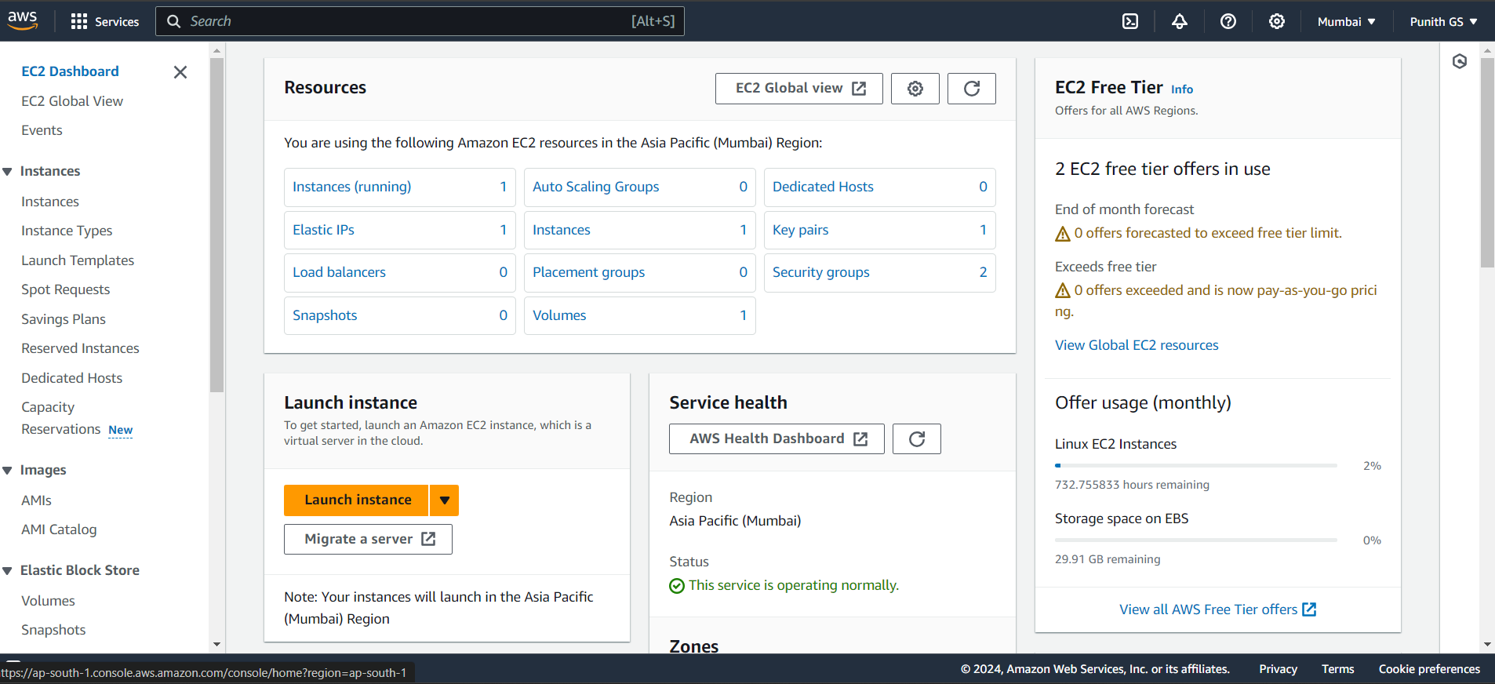

**Step 2:**

You launch a basic default Instance

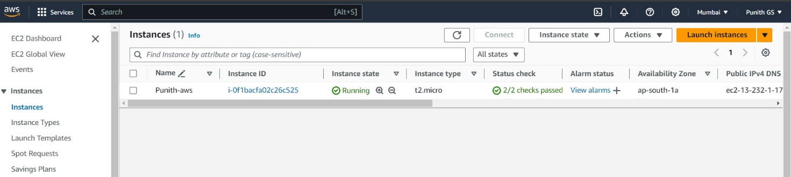

**Step 3:**

Add a new inbound rule to insert HTTP Link and make sure it’s at port 80

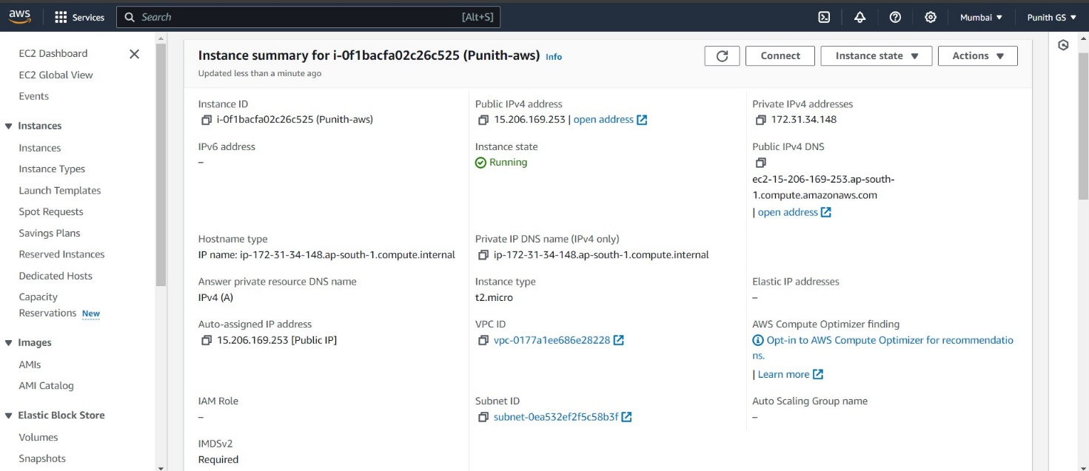

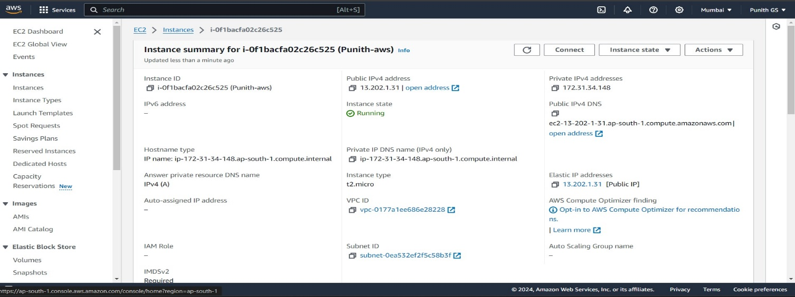

**Step 4:**

**Connection of Instances:**

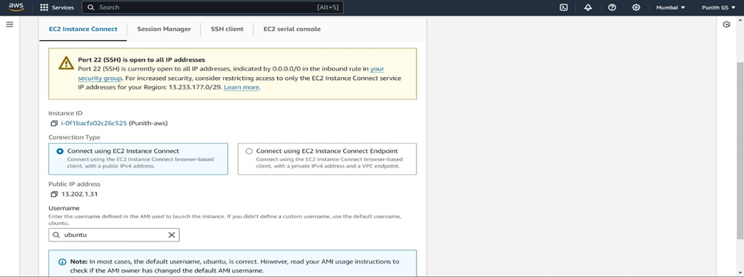

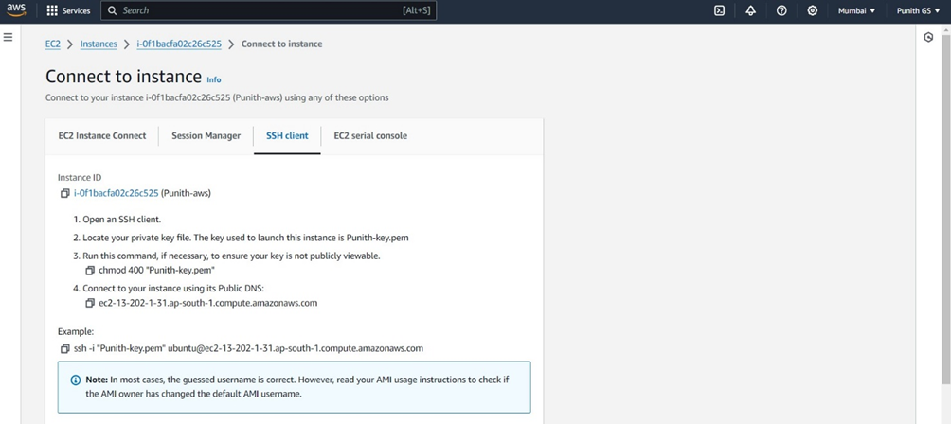

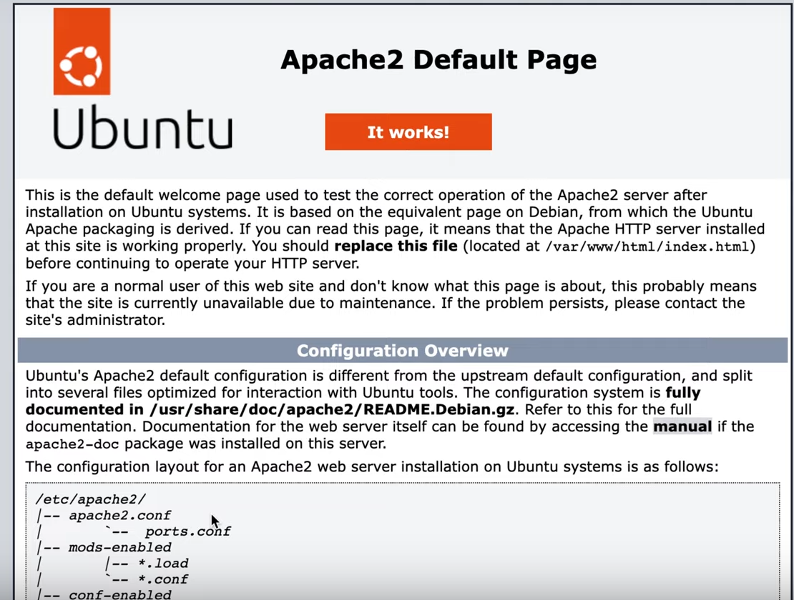 **AWS Amplify**

Amazon Amplify is a set of tools and services provided by Amazon Web Services (AWS) designed to help developers build scalable and secure full-stack applications quickly. It simplifies the process of developing web and mobile applications by providing a comprehensive suite of services for frontend and backend development, authentication, data storage, and more.

**Introduction:**

Amazon Amplify provides developers with a set of tools and services to accelerate the development of web and mobile applications. It offers a unified platform for frontend and backend development, simplifying tasks such as user authentication, data storage, and API integration. Amplify supports popular frontend frameworks such as React, Angular, and Vue.js, as well as mobile platforms like iOS and Android.

**Advantages:**

1. **Rapid Development**: Amplify accelerates the development process by providing pre-built components and services for common tasks such as authentication, data storage, and file storage, allowing developers to focus on building features unique to their application.
2. **Scalability**: Applications built with Amplify can easily scale to accommodate growing user bases and increased demand. Amplify leverages AWS's global infrastructure, which provides high availability and low latency for users worldwide.
3. **Security**: Amplify incorporates best practices for security into its services, including built-in authentication and authorization mechanisms, data encryption, and protection against common security threats.
4. **Serverless Architecture**: Amplify encourages the use of serverless computing models, where the backend logic is implemented using AWS Lambda functions, eliminating the need for managing servers and infrastructure.
5. **Integration with AWS Services**: Amplify seamlessly integrates with other AWS services such as Amazon DynamoDB, Amazon S3, and AWS AppSync, allowing developers to leverage the full capabilities of the AWS ecosystem in their applications.

**Disadvantages:**

1. **Learning Curve**: While Amplify simplifies many aspects of application development, it still requires developers to learn the Amplify CLI and understand AWS services and configurations, which can be challenging for beginners.
2. **Vendor Lock-in**: Applications built with Amplify are tightly coupled with AWS services, which can make it difficult to migrate to other platforms in the future.
3. **Complexity for Advanced Use Cases**: While Amplify is well-suited for building standard web and mobile applications, it may not be the best choice for complex or highly customized projects that require fine-grained control over the infrastructure and architecture.

**Applications:**

1. **Web and Mobile Applications**: Amplify is ideal for building a wide range of web and mobile applications, including e-commerce sites, social media platforms, and productivity apps.
2. **Progressive Web Apps (PWAs)**: Amplify supports the development of PWAs, which are web applications that offer a native app-like experience on mobile devices, including offline capabilities and push notifications.
3. **Real-time Applications**: Amplify integrates with AWS AppSync, a managed GraphQL service, making it easy to build real-time applications such as chat apps, collaboration tools, and live streaming platforms.
4. **Content Management Systems (CMS)**: Amplify can be used to build custom CMS solutions for managing and delivering content to websites and mobile apps, with features such as user authentication, content editing, and versioning.

**Launching Ubuntu Virtual Machine Repository:**

**Step 1:**

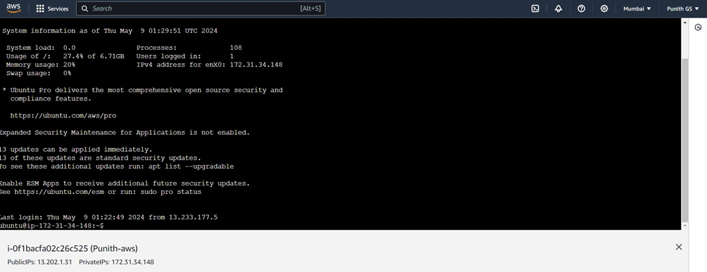

**Step 2:**

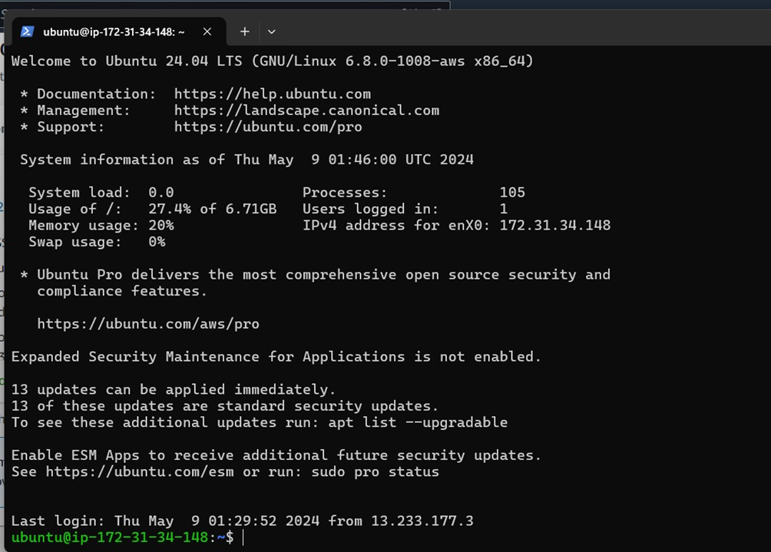

**Step 3:**

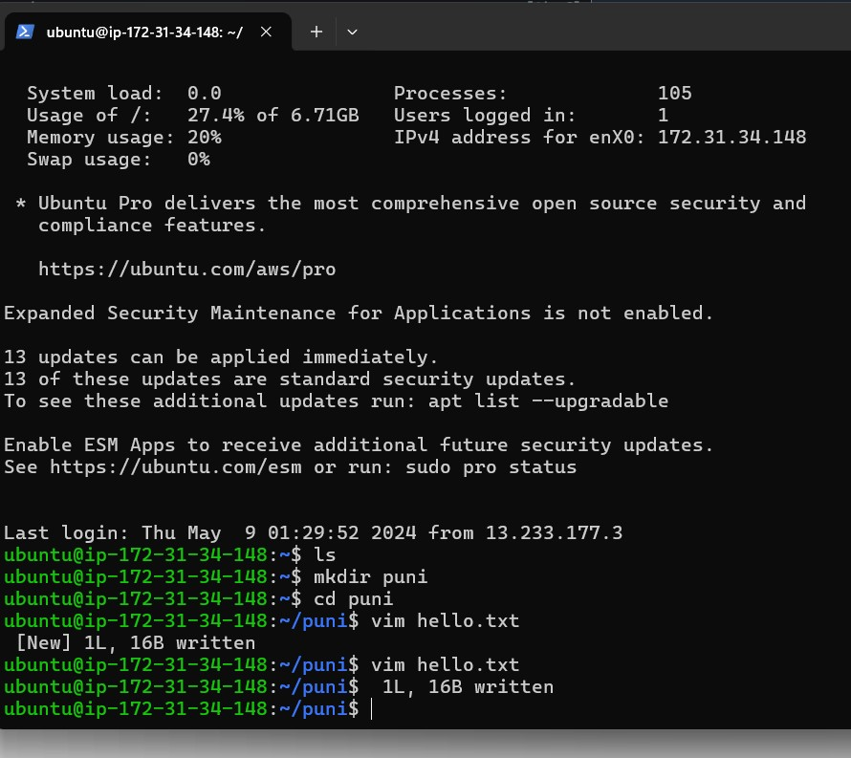

**SIMPLE STORAGE SREVICES (S3)**

**INTRODUCTION:**

Amazon Simple Storage Service (S3) stands as a cornerstone in cloud computing, providing a secure, scalable, and highly available storage solution since its inception in 2006. S3 simplifies the storage of vast amounts of data, organizing it into buckets that are accessible globally via unique URLs. Its scalability is unparalleled, effortlessly accommodating the storage needs of users without requiring upfront planning or management of infrastructure. Crucially, S3 ensures the durability and availability of stored data by redundantly storing it across multiple geographically dispersed data centers, backed by an SLA guaranteeing exceptional durability and availability. Security is a top priority, with robust encryption options and access controls through IAM, bucket policies, and ACLs.

Moreover, S3 offers a cost-effective pay-as-you-go pricing model, making it suitable for a diverse range of use cases, from frequently accessed data to archival storage. Its rich set of features for data management, including versioning, object tagging, and lifecycle policies, enables users to automate tasks and ensure compliance. With seamless integration with other AWS services, S3 empowers organizations to build scalable, cost-effective solutions for data storage, analytics, content delivery, and more, freeing them to focus on innovation and growth.

**Advantages of Amazon Simple Storage Service**

**Scalability**: S3 is designed to scale effortlessly, allowing users to store and retrieve any amount of data, from gigabytes to petabytes, without worrying about capacity constraints. It seamlessly handles fluctuating workloads and growing storage needs.

**Durability and Availability:** S3 provides exceptional durability and availability by storing data redundantly across multiple geographically dispersed data centers. It offers a service-level agreement (SLA) guaranteeing 99.999999999% (11 nines) durability and 99.99% availability, ensuring that data is always accessible.

**Security**: S3 prioritizes security, offering multiple layers of protection for data at rest and in transit. This includes server-side encryption, client-side encryption, access control through bucket policies and access control lists (ACLs), and integration with AWS Identity and Access Management (IAM) for fine-grained access control.

**Cost-effectiveness:** S3 operates on a pay-as-you-go pricing model, where users only pay for the storage capacity they consume and any data transfer costs associated with accessing their data. This pricing model makes it cost-effective for storing a wide range of data types, from frequently accessed data to long-term archival data.

**Data Management:** S3 provides powerful features for managing data lifecycle, including versioning, object tagging, cross-region replication, and event notifications. These features enable users to automate data management tasks, enforce retention policies, and ensure compliance with regulatory requirements.

**Integration:** S3 seamlessly integrates with other AWS services, such as Amazon Elastic Compute Cloud (EC2), Amazon Glacier (for long-term archival storage), AWS Lambda (serverless computing), and Amazon CloudFront (content delivery network). This integration enables users to build scalable and cost-effective solutions for various use cases, including data analytics, media distribution, backup and recovery, and web hosting.

**Disadvantages of Amazon Simple Storage Service**

**Cost Complexity**: While S3's pay-as-you-go pricing model can be cost-effective, it can also lead to complex billing structures, especially for organizations with large amounts of data or fluctuating storage needs. Users need to carefully monitor their usage and understand the pricing tiers to avoid unexpected costs.

**Data Transfer Costs:** While data stored within S3 is typically free, there are costs associated with transferring data into and out of S3, particularly when accessing data from different AWS regions or using services outside of AWS. These data transfer costs can accumulate, especially for applications with high data ingress or egress.

**Performance Variability:** While S3 offers high availability and durability, the performance of individual requests can vary depending on factors such as network latency, request volume, and the size and location of objects. Applications requiring low-latency access to data may need to consider caching strategies or alternative storage solutions.

**Limited Consistency Model:** S3 provides eventual consistency for data operations, meaning that changes made to objects may not be immediately reflected in all copies of the data. While this consistency model is suitable for many applications, it may not be appropriate for applications requiring strict consistency guarantees.

**Limited Access Control Granularity:** While S3 offers robust access control mechanisms, including bucket policies, ACLs, and IAM roles, it may lack the granularity needed for certain access control requirements. Fine-grained access control may require additional third-party solutions or custom implementations.

**Data Governance and Compliance:** Organizations operating in regulated industries or subject to data governance requirements may face challenges in ensuring compliance when using S3. While S3 provides features for encryption, access control, and auditing, organizations may need to implement additional controls and processes to meet regulatory obligations.

**Vendor Lock-In:** Relying heavily on Amazon S3 for storage needs may lead to vendor lock-in, making it challenging to migrate data and applications to alternative cloud providers or on-premises environments in the future. Organizations should carefully evaluate the trade-offs and consider strategies for mitigating vendor lock-in risks.

**STEPS TO IMPLEMENT AMAZON SIMPLE STORAGE SERVICE**

1. **AWS S3 Homepage**

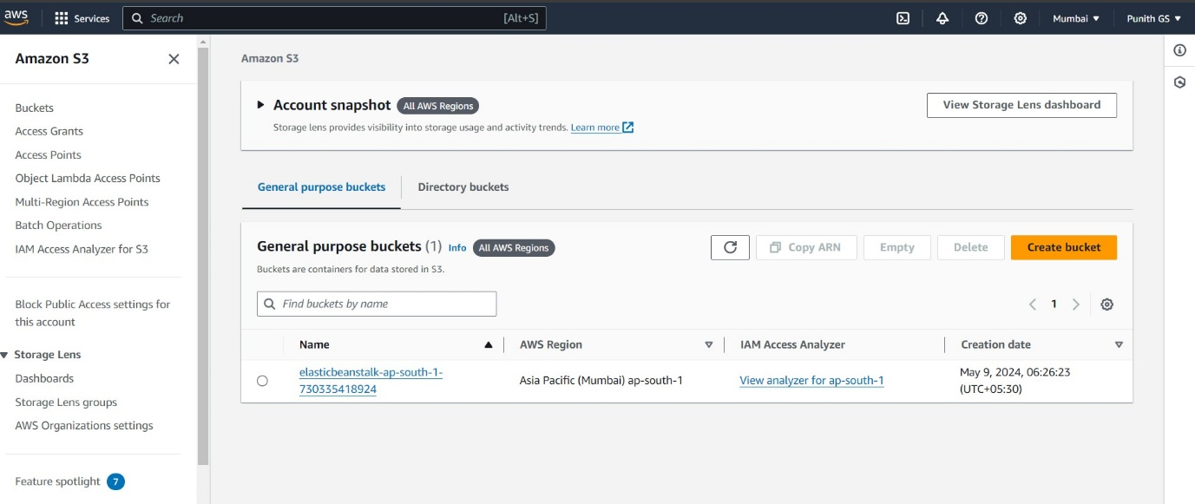

1. **Create Bucket**

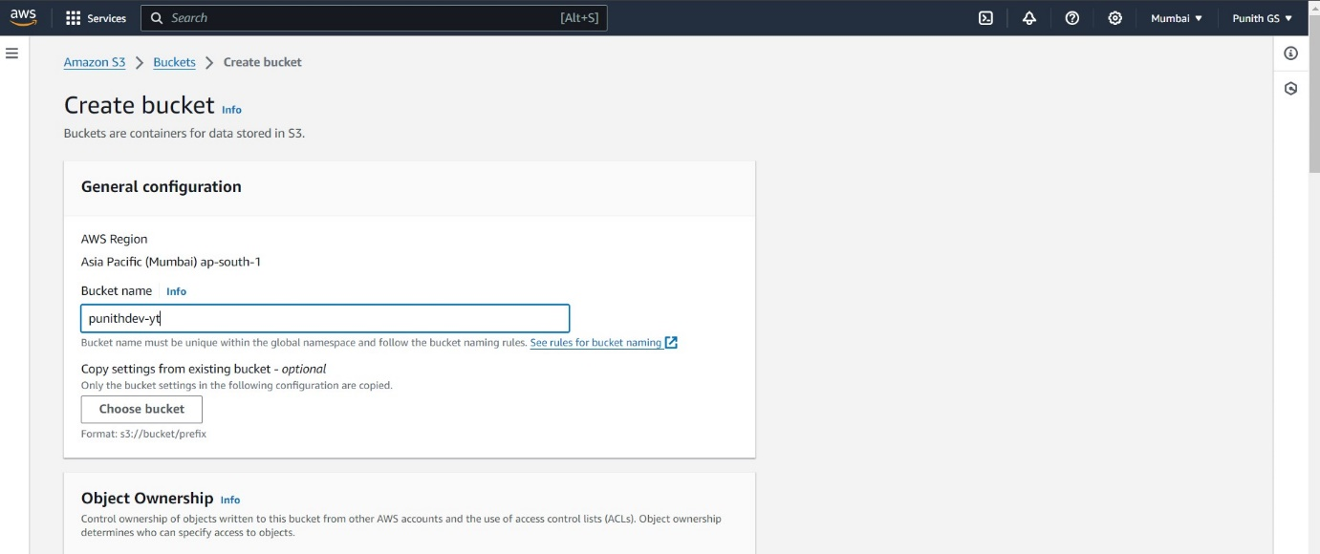

1. Document Upload

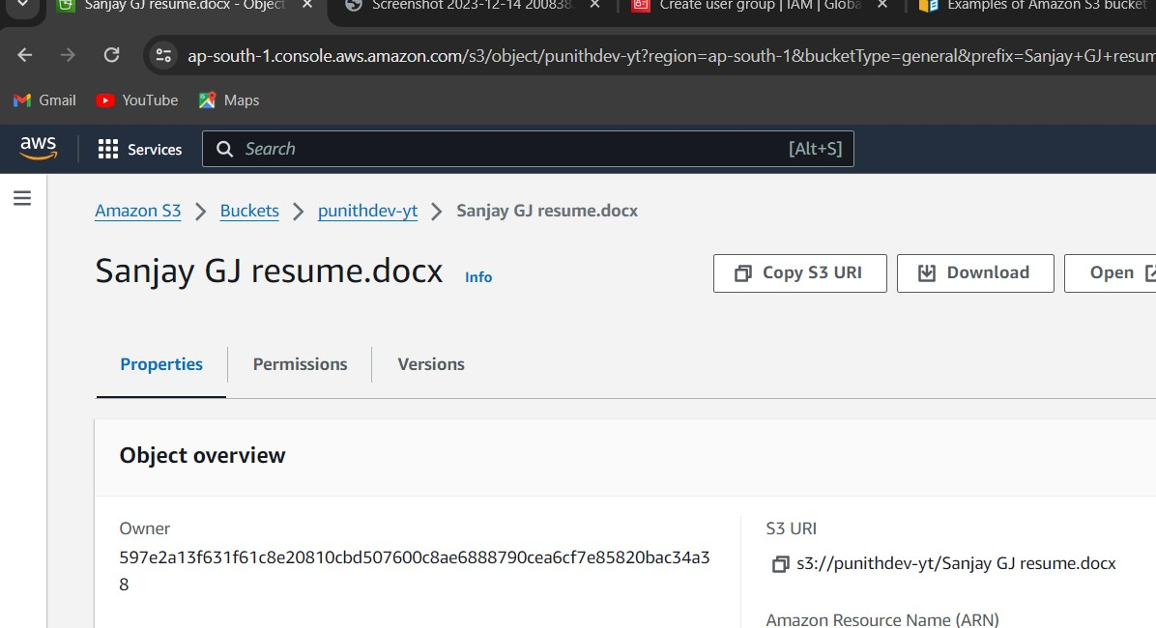

1. **Screenshot Upload**

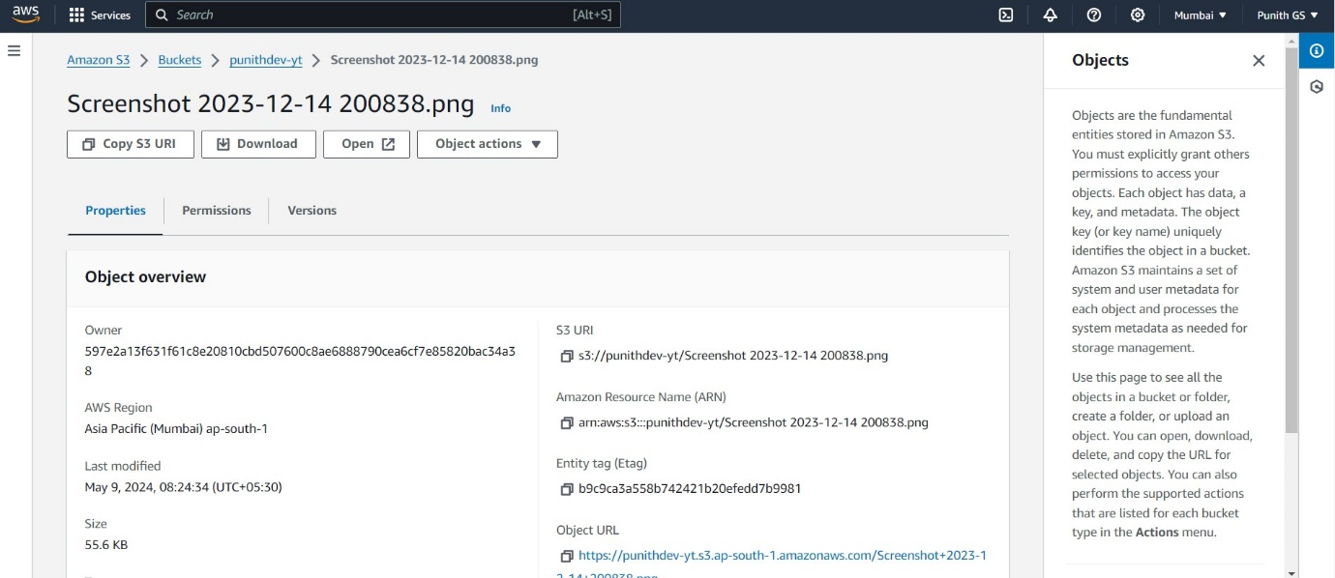

1. Image are Uploaded in cloud storage (in public)

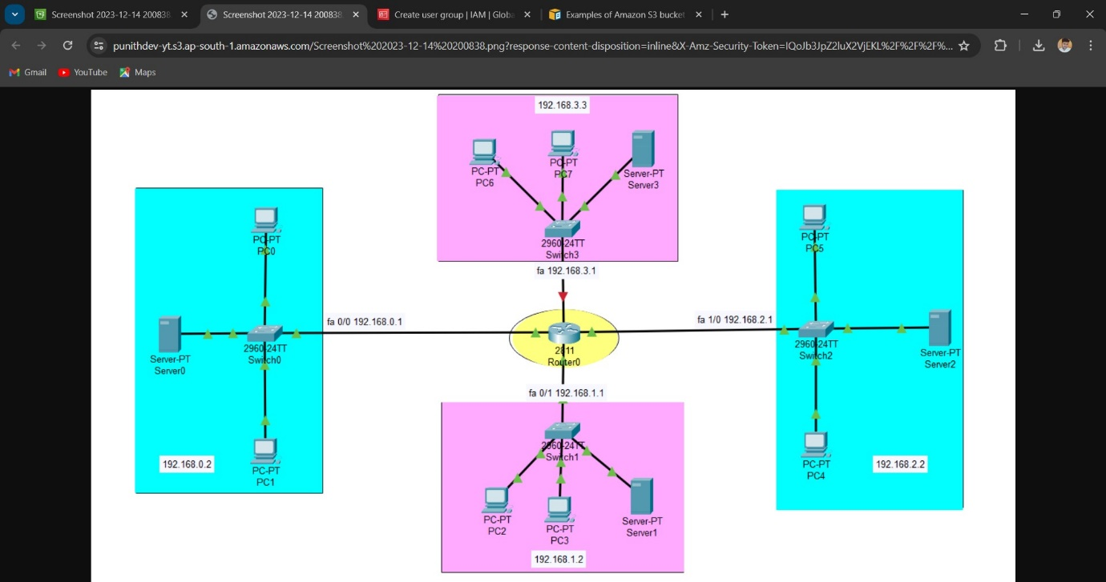

**Amazon DynamoDB**

Amazon DynamoDB is a fully managed NoSQL database service provided by Amazon Web Services (AWS). It offers seamless scalability with high performance and low latency for applications requiring fast and predictable performance at any scale. DynamoDB is designed to handle large volumes of data and high traffic loads with built-in security, backup, and restore capabilities. It supports both document and key-value data models, providing flexibility for various use cases

Introduction:

DynamoDB allows users to create databases capable of storing and retrieving any amount of data and comes in handy while serving any amount of traffic. It dynamically manages each customer’s requests and provides high performance by automatically distributing data and traffic over servers. It is a fully managed NoSQL database service that is fast, predictable in terms of performance, and seamlessly scalable. It relieves the user from the administrative burdens of operating and scaling a distributed database as the user doesn’t have to worry about hardware provisioning, patching Softwares, or cluster scaling. It also eliminates the operational burden and complexity involved in protecting sensitive data by providing encryption at REST..

Advantages:

1. Scalability: DynamoDB scales seamlessly to handle any amount of traffic and data, from a few megabytes to petabytes, without requiring any downtime or manual intervention.
2. Performance: It delivers single-digit millisecond response times, ensuring fast and predictable performance for applications with high throughput and low latency requirements.
3. Fully Managed: DynamoDB is a fully managed service, which means AWS handles infrastructure provisioning, patching, backups, and maintenance tasks, allowing developers to focus on building applications rather than managing databases.
4. Flexible Data Models: It supports both document and key-value data models, providing flexibility for different types of applications and use cases.
5. Built-in Security: DynamoDB offers encryption at rest and in transit, fine-grained access control using AWS Identity and Access Management (IAM), and integration with AWS Key Management Service (KMS) for managing encryption keys.

Disadvantages:

1. Cost: While DynamoDB's pay-per-request pricing model can be cost-effective for certain workloads, it can become expensive for high-throughput or large-scale applications.
2. Complexity: DynamoDB's flexibility and scalability come with a learning curve. Setting up and optimizing DynamoDB tables, especially for complex use cases, can be challenging.
3. Limited querying capabilities: DynamoDB's querying capabilities are limited compared to traditional relational databases. It doesn't support complex SQL queries, joins, or secondary indexes as comprehensively.

Applications:

1. Web and Mobile Applications: DynamoDB is often used as the backend database for web and mobile applications due to its ability to handle massive amounts of traffic and data with low latency.
2. Gaming: In the gaming industry, DynamoDB can store player data, game state information, and user preferences, providing a reliable and scalable backend for multiplayer games and leaderboards.
3. IoT (Internet of Things): DynamoDB is suitable for storing and querying large volumes of IoT sensor data, such as temperature readings, device statuses, and telemetry data, enabling real-time analytics and monitoring.
4. Ad Tech: Ad tech companies use DynamoDB to store user profiles, ad campaign data, and clickstream information, allowing for real-time targeting and personalized advertising.
5. E-commerce: DynamoDB powers product catalogs, user sessions, shopping carts, and order management systems in e-commerce platforms, ensuring high availability and performance during peak shopping seasons.

**IMPLEMENTATION OF DYNAMODB SERVICES**

**Step 1:**

**Create table**

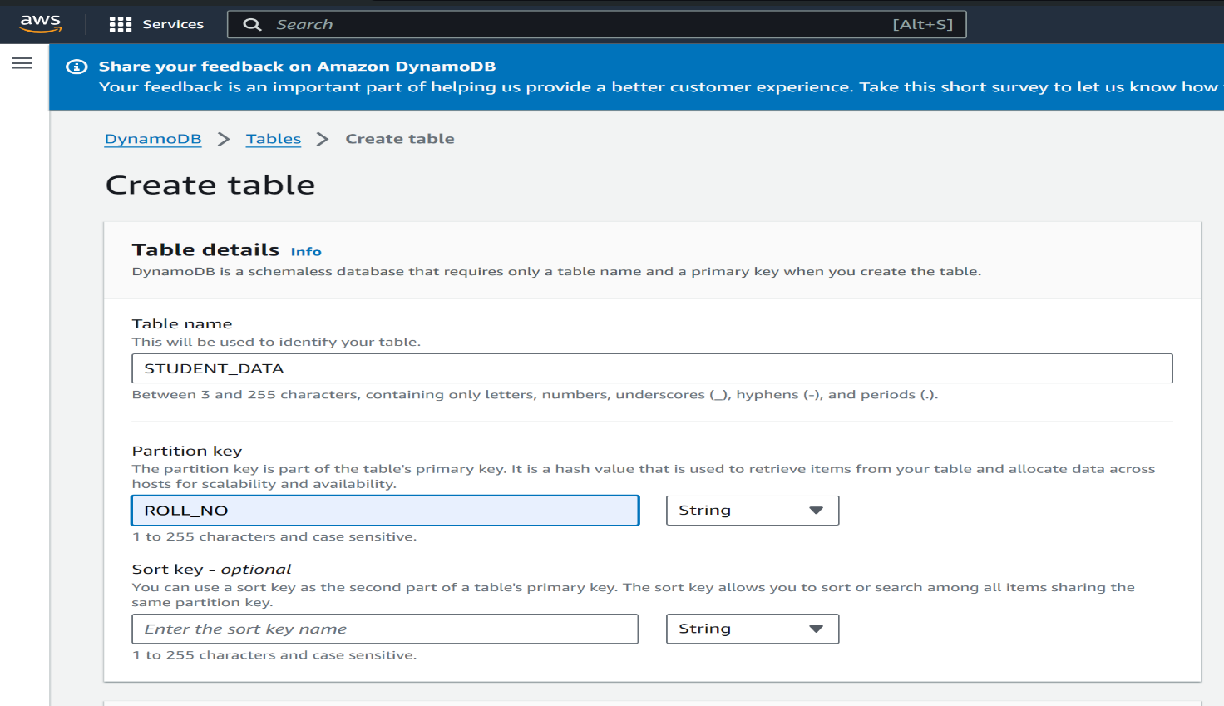

**Step 2: Table name**

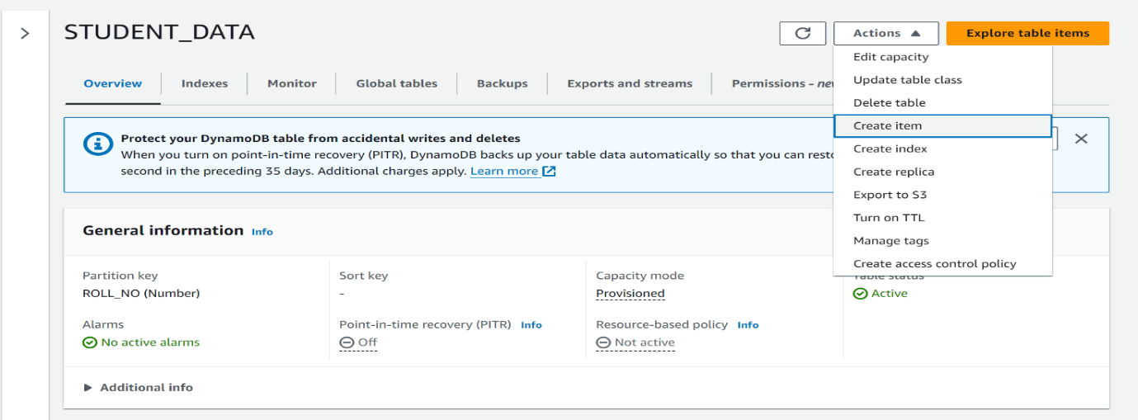

**Step 3: Insert items**

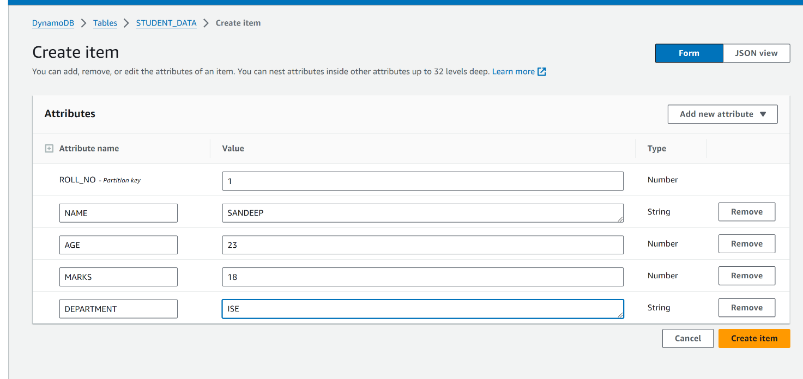

**Step 4: Item result**



**Step 5: Filters**

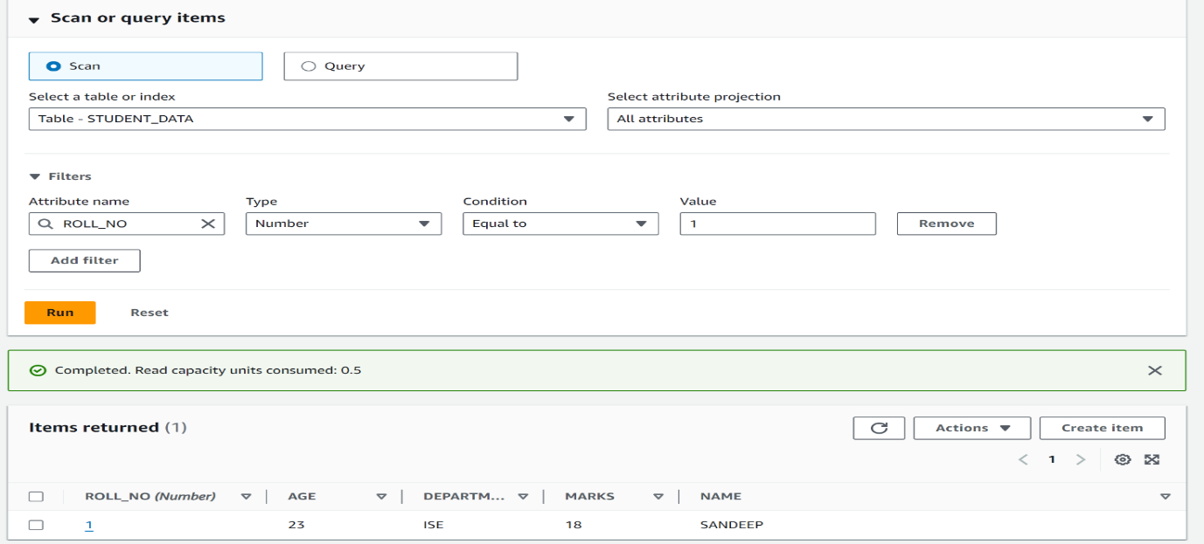

**Amazon SNS (Simple Notification Service)**

Amazon Simple Notification Service (SNS) is a fully managed messaging service provided by Amazon Web Services (AWS) that enables developers to build distributed systems and applications capable of sending notifications to subscribers or other distributed services.

SNS operates on a publish-subscribe model, where publishers send messages to topics, and subscribers receive messages from those topics. This decouples the sender of a message from its recipients, allowing for flexible and scalable communication patterns..

Introduction:

Amazon Simple Notification Service (SNS) is a fully managed messaging service provided by Amazon Web Services (AWS) that enables developers to build distributed systems and applications capable of sending notifications to a large number of subscribers or distributed services.

With SNS, developers can send notifications to a variety of endpoints, including mobile devices (iOS, Android), email, SMS text messages, HTTP/S endpoints, AWS Lambda functions, and more. It follows a publish-subscribe (pub/sub) messaging paradigm, where publishers send messages to topics, and subscribers receive messages from those topics. This decouples the sender of a message from its recipients, allowing for scalable and flexible communication between different components of an application or system.

Advantages:

1. Scalability: SNS is designed to scale seamlessly to accommodate any volume of messages, enabling applications to send notifications to a large number of subscribers with low latency and high throughput.
2. Reliability: SNS provides highly reliable message delivery with automatic retries and redundant infrastructure across multiple Availability Zones, ensuring that messages are delivered reliably even in the event of failures or network issues.
3. Flexibility: SNS supports a wide range of message delivery protocols, including SMS, email, mobile push notifications (iOS, Android), HTTP/S endpoints, AWS Lambda functions, and more, allowing developers to choose the most appropriate delivery method for their use case.
4. Simple Integration: SNS integrates seamlessly with other AWS services, such as Amazon SQS, AWS Lambda, Amazon S3, and Amazon CloudWatch, enabling developers to build scalable and event-driven architectures with ease.
5. Publish-Subscribe Model: SNS follows a publish-subscribe messaging paradigm, allowing publishers to send messages to topics without needing to know the identity of the subscribers. This decouples the sender from the receiver, enabling flexible and loosely coupled architectures.

Disadvantages:

1. Costs: While the pay-as-you-go pricing model can be cost-effective for many use cases, the costs of sending notifications can add up, especially at scale. Developers should carefully monitor their usage and optimize message delivery to avoid unexpected expenses.
2. Limited Message Size: SNS has a maximum message size limit of 256 KB for direct delivery to HTTP/HTTPS endpoints and 256 KB for delivery to email, SMS, and mobile push endpoints. This limitation may require developers to break up larger messages or use alternate methods for delivering large payloads.
3. Message Delivery Guarantees: While SNS strives for high reliability and availability, it does not offer strict message delivery guarantees. In some cases, messages may be delayed or dropped due to network issues, transient failures, or other factors beyond the user's control.

Applications:

1. Push Notifications: Mobile app developers use SNS to send push notifications to iOS, Android, and other mobile devices. This is often used in messaging apps, social media platforms, news apps, and e-commerce apps to alert users about new messages, updates, promotions, or important events.
2. Alerts and Monitoring: SNS is used for real-time monitoring and alerting in systems and applications. It can integrate with AWS services like Amazon CloudWatch to send alerts when specific thresholds are exceeded, such as high CPU usage, low disk space, or application errors. This is crucial for maintaining the health and performance of cloud-based applications.
3. Event-Driven Architectures: SNS plays a key role in event-driven architectures, where different services communicate asynchronously via messages. It enables services to react to events or triggers in real-time, such as processing data streams, handling user actions, or triggering automated workflows. AWS Lambda functions can subscribe to SNS topics to execute custom logic in response to events.
4. Distributed Systems: SNS facilitates communication between microservices in distributed systems. Services can publish messages to SNS topics to notify other services about state changes, updates, or important events. This helps decouple components and enables a more scalable and resilient architecture.
5. Email and SMS Notifications: Organizations use SNS to send email and SMS notifications to customers, employees, or stakeholders. This is useful for sending transactional emails (e.g., order confirmations, password resets) or important alerts (e.g., service outages, security incidents) via SMS.

**IMPLEMENTATION OF SNS SERVICES**

**Step 1: Create topic**

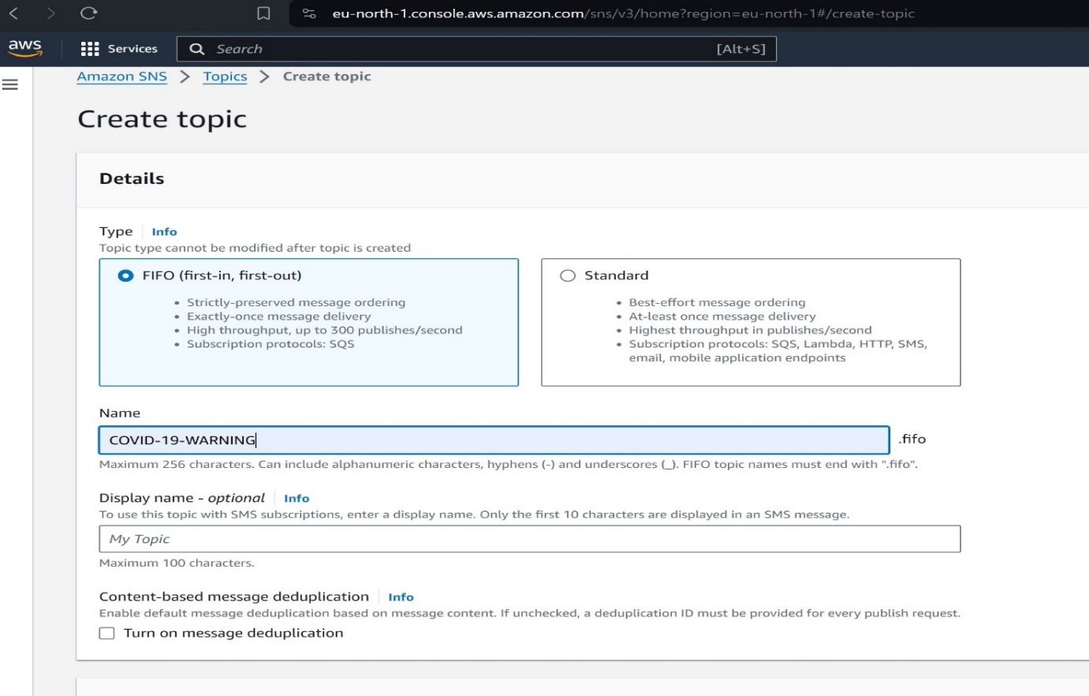

**Step 2:Create subscription**

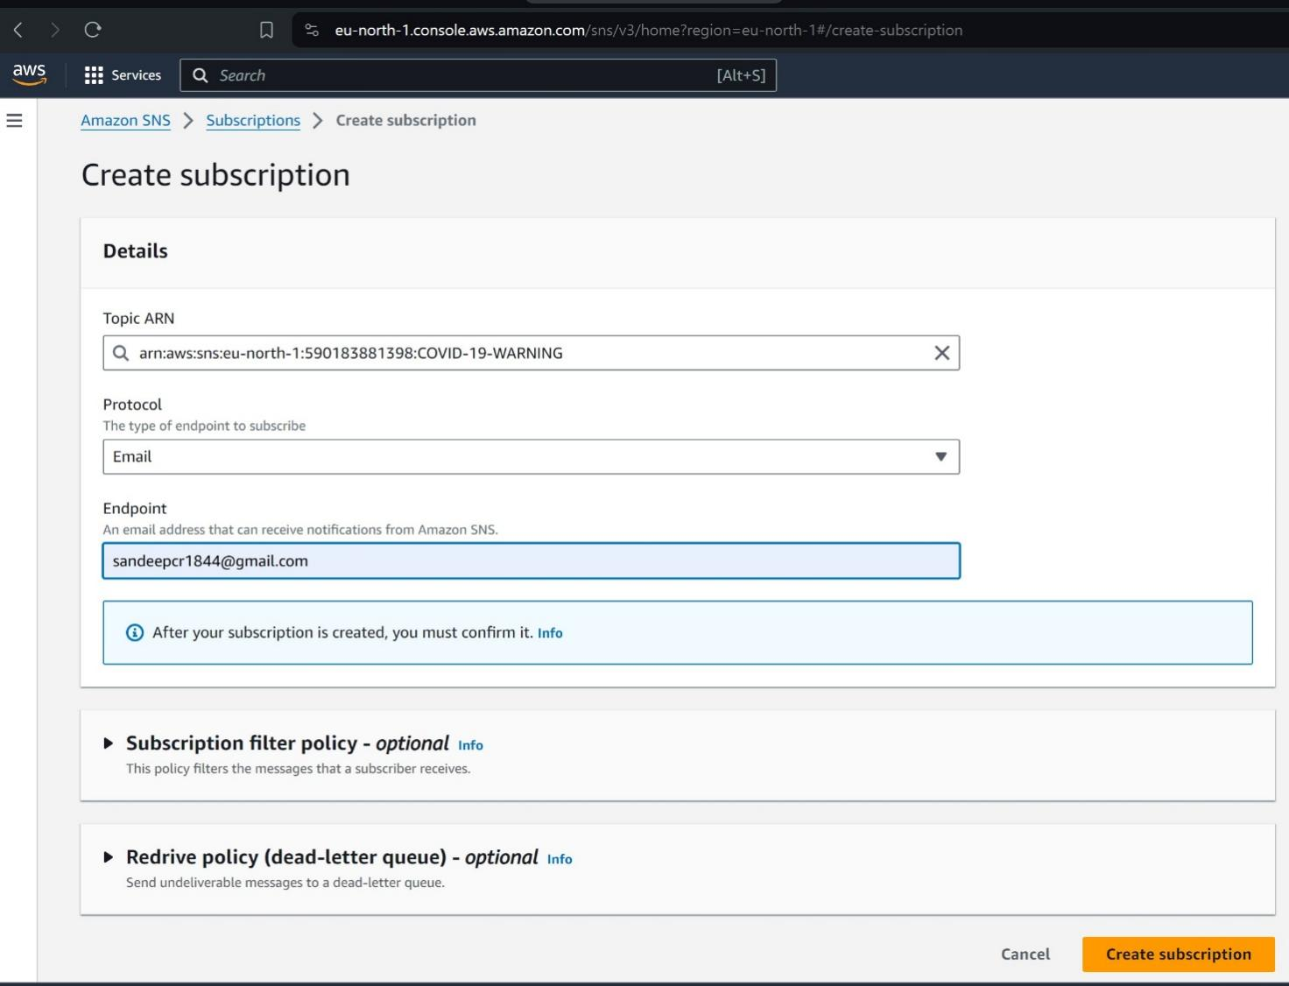

**Step 3: Confirm subscription**

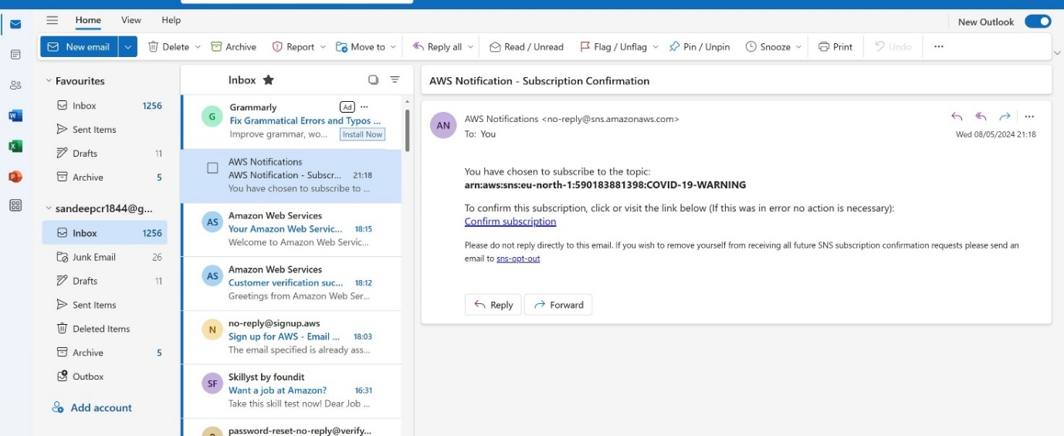

**Step 4: E-mail**

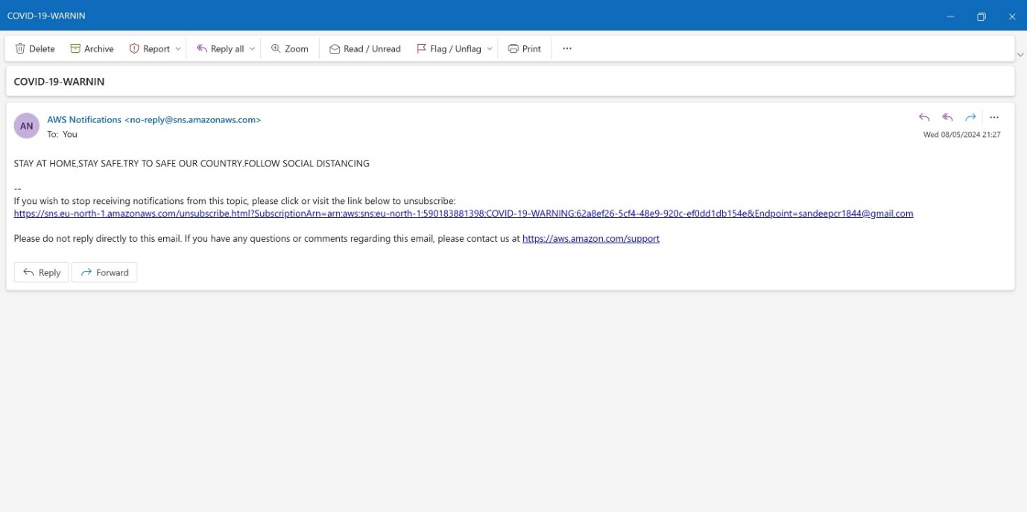

**Step 5: Publish SMS message**

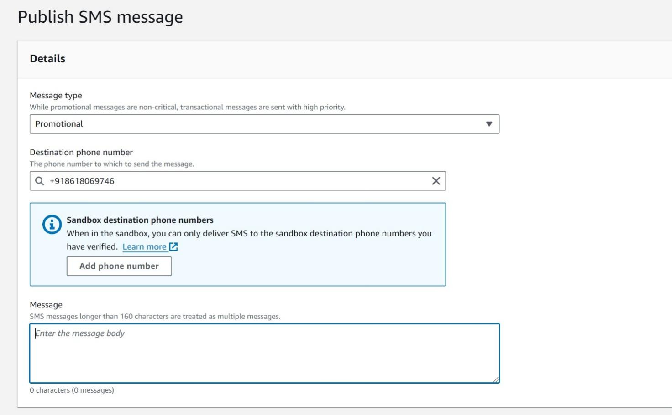

**Step 5: OTP message**



**Step 5: Normal message**

